Deployment object to host n number of identical pods and manage them automatically

some commands:

#change image name in client-pod.yaml

#then use apply

$ kubectl apply –f client-pod.yaml

$kubectl get pods

$kubectl desribe pod client-pod

#delete an existing object

$ kubectl delete –f client-pod.yaml

$ kubectl delete –f client-node-port.yaml

#create deployment object and associated containers:

$ kubectl apply –f client-deployment.yaml

$ kubectl get deployments

$kubectl get pods –o wide

#connect to container in the deployment object:

localhost:31515

UPDATING DEPLOYMENT IMAGES:

client-deployment.yaml:

apiVersion: apps/v1

kind: Deployment

metadata:

name: client-deployment

spec:

replicas: 3

selector:

matchLabels:

component: web

template:

metadata:

labels:

component: web

spec:

containers:

- name: client

image: stephengrider/multi-client

ports:

- containerPort: 3000

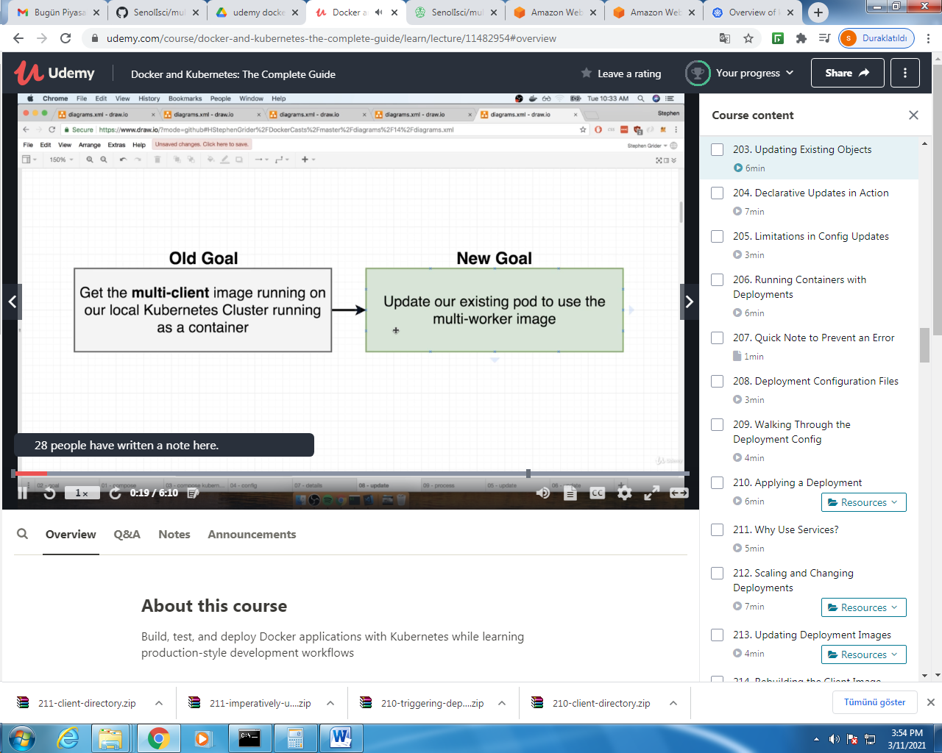

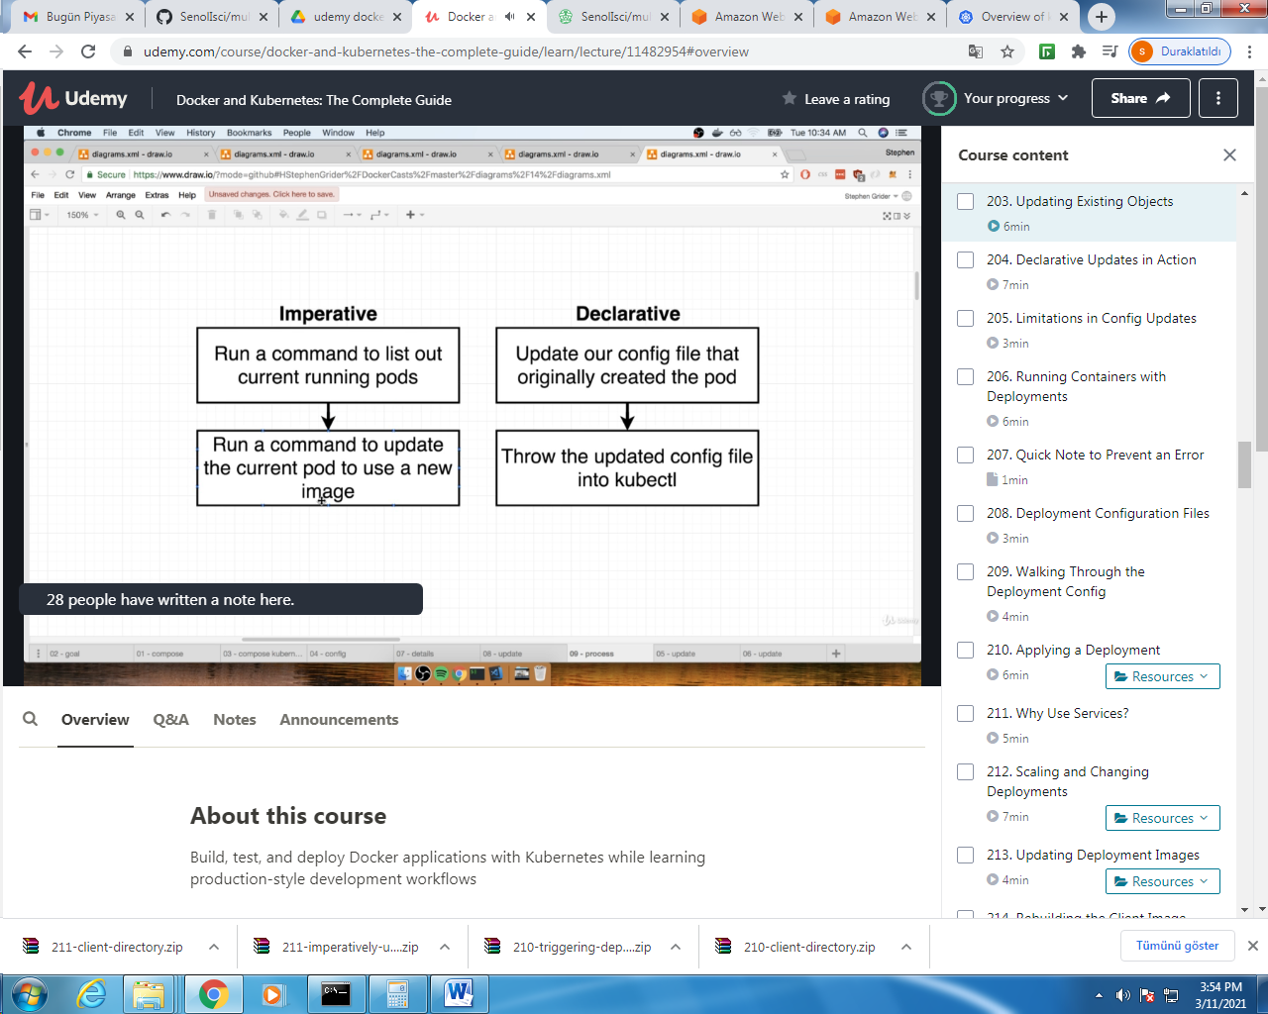

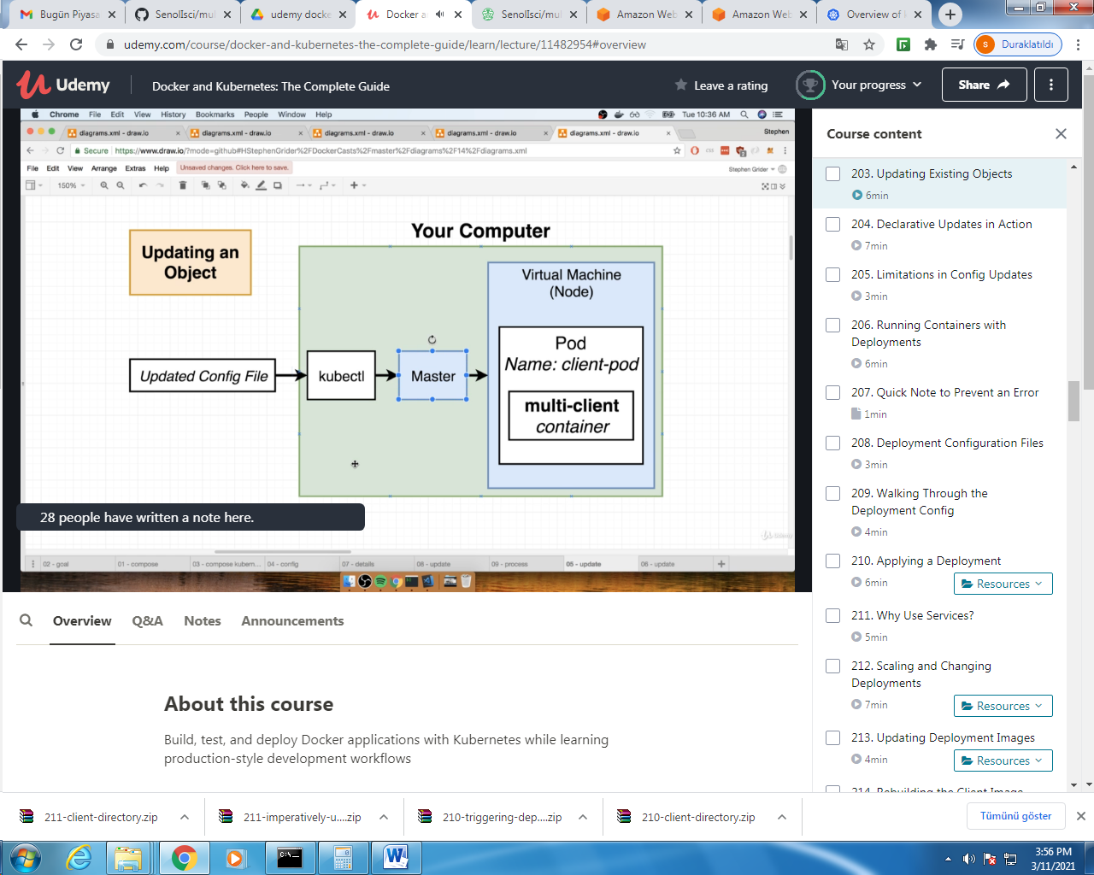

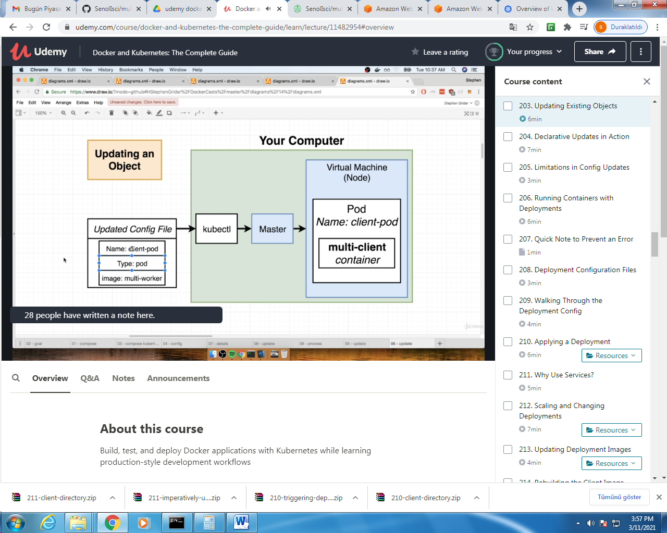

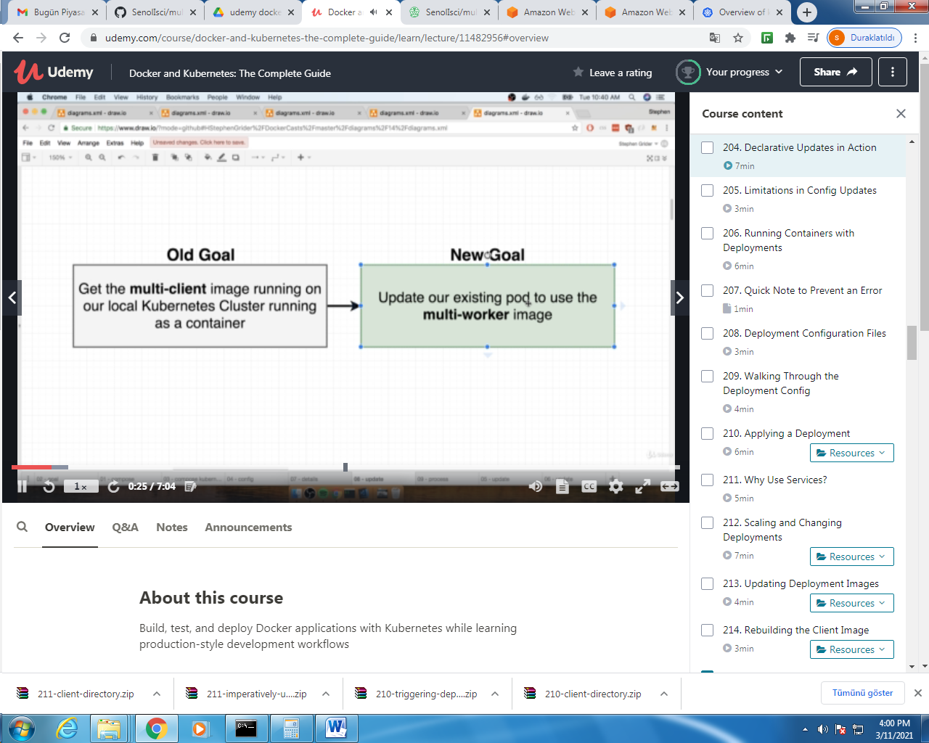

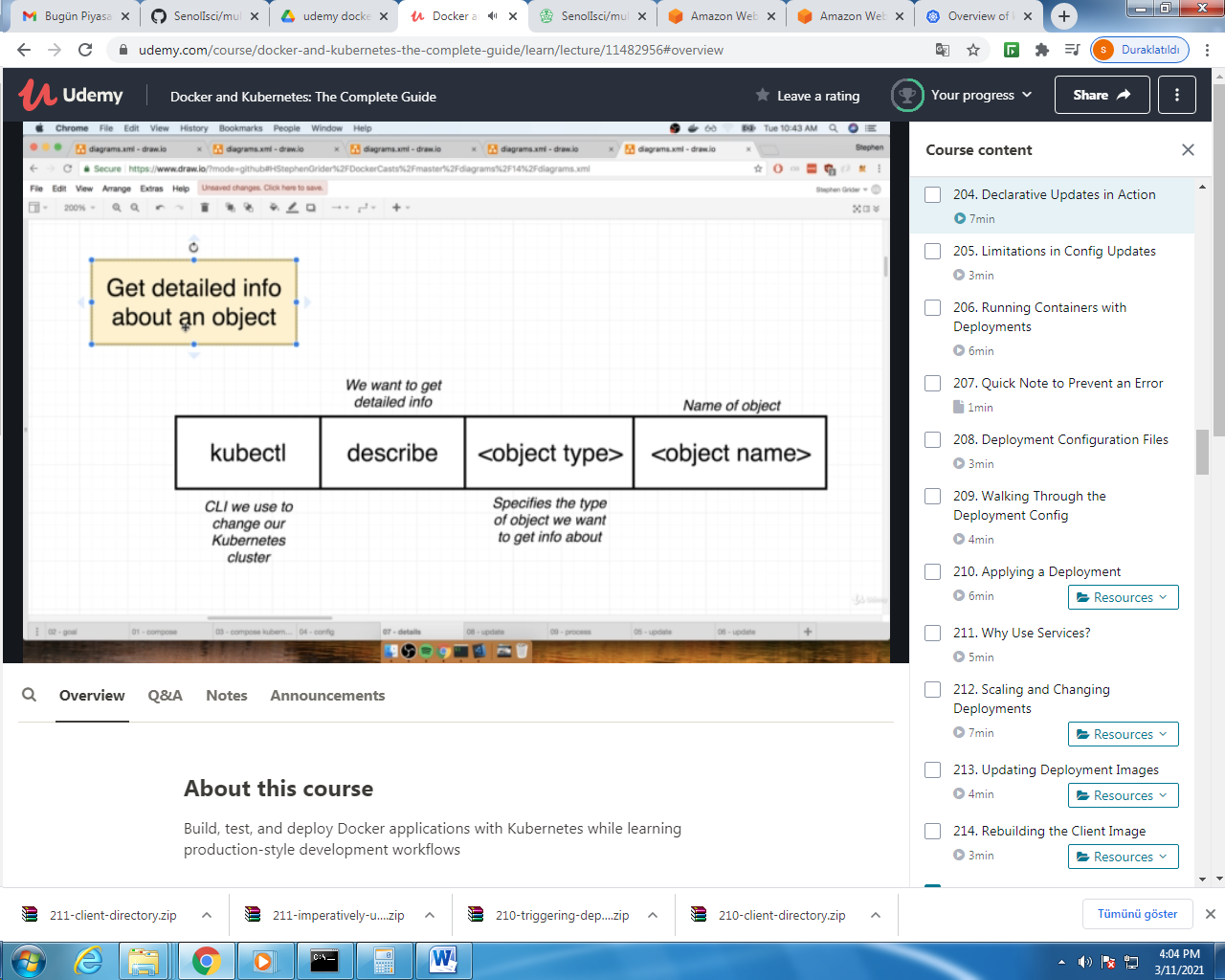

#change image name in client-pod.yaml

#then use apply

$ kubectl apply –f client-pod.yaml

$kubectl get pods

$kubectl desribe pod client-pod

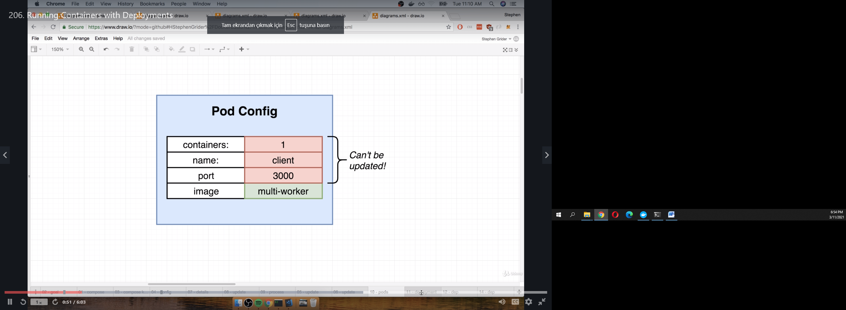

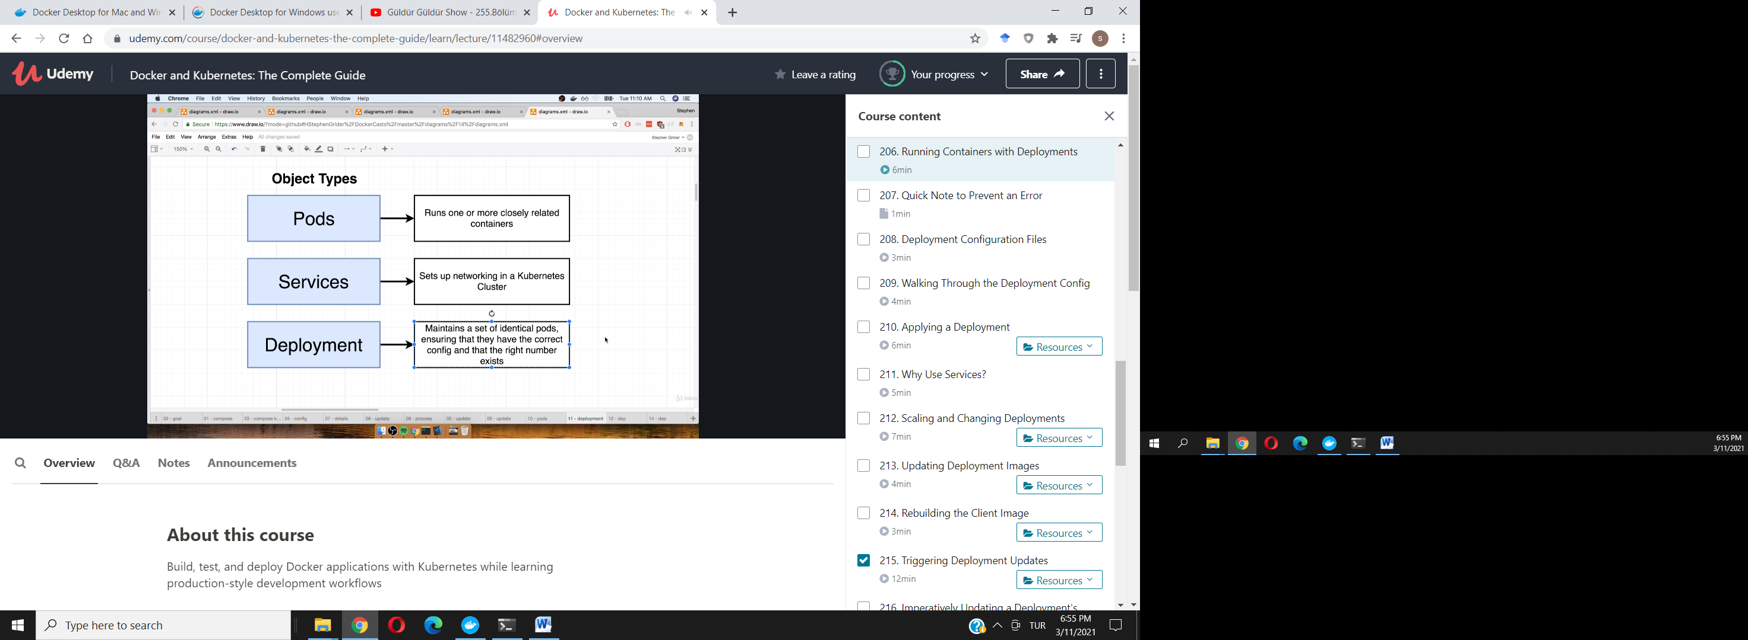

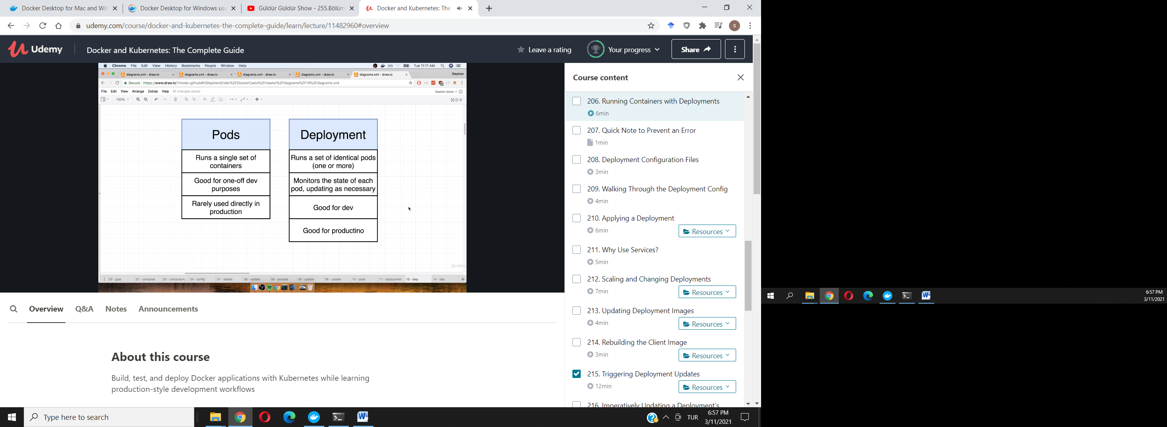

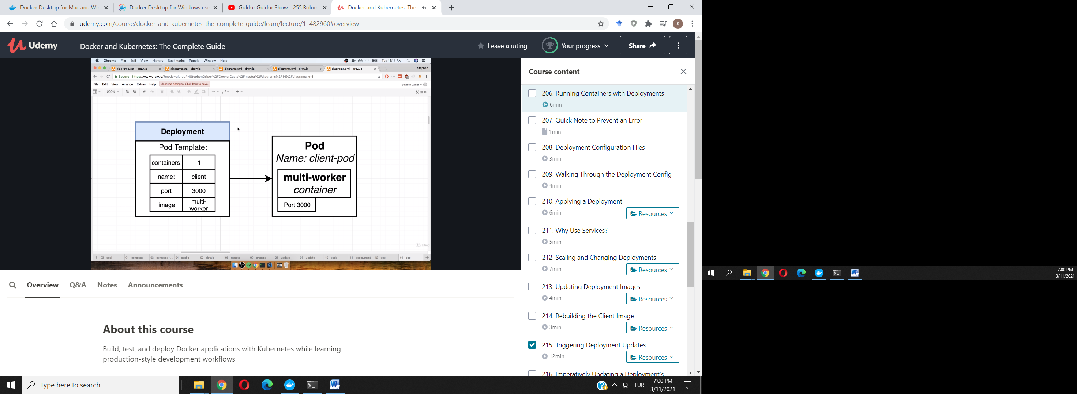

client-deployment.yaml:

apiVersion: apps/v1

kind: Deployment

metadata:

name: client-deployment

spec:

replicas: 1

selector:

matchLabels:

component: web

template:

metadata:

labels:

component: web

spec:

containers:

- name: client

image: stephengrider/multi-client

ports:

- containerPort: 3000

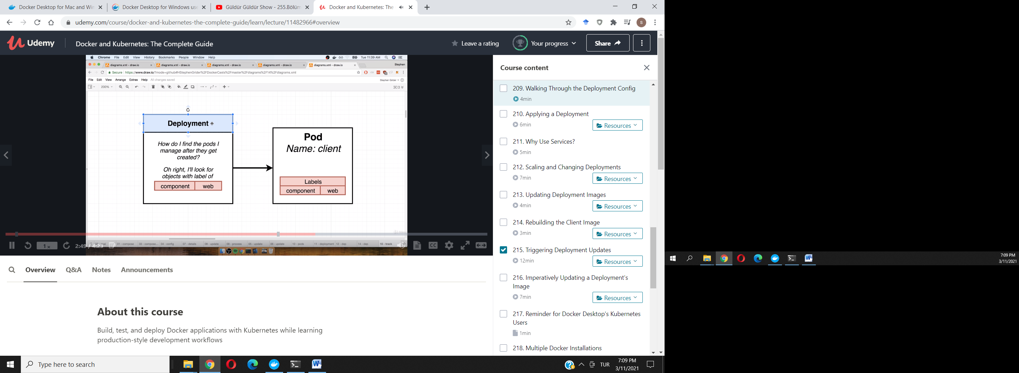

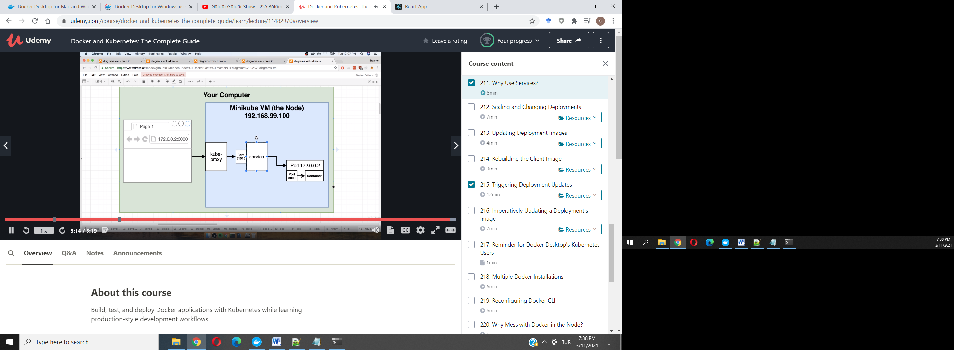

UPDATING IMAGES IN DEPLOYMENTS:

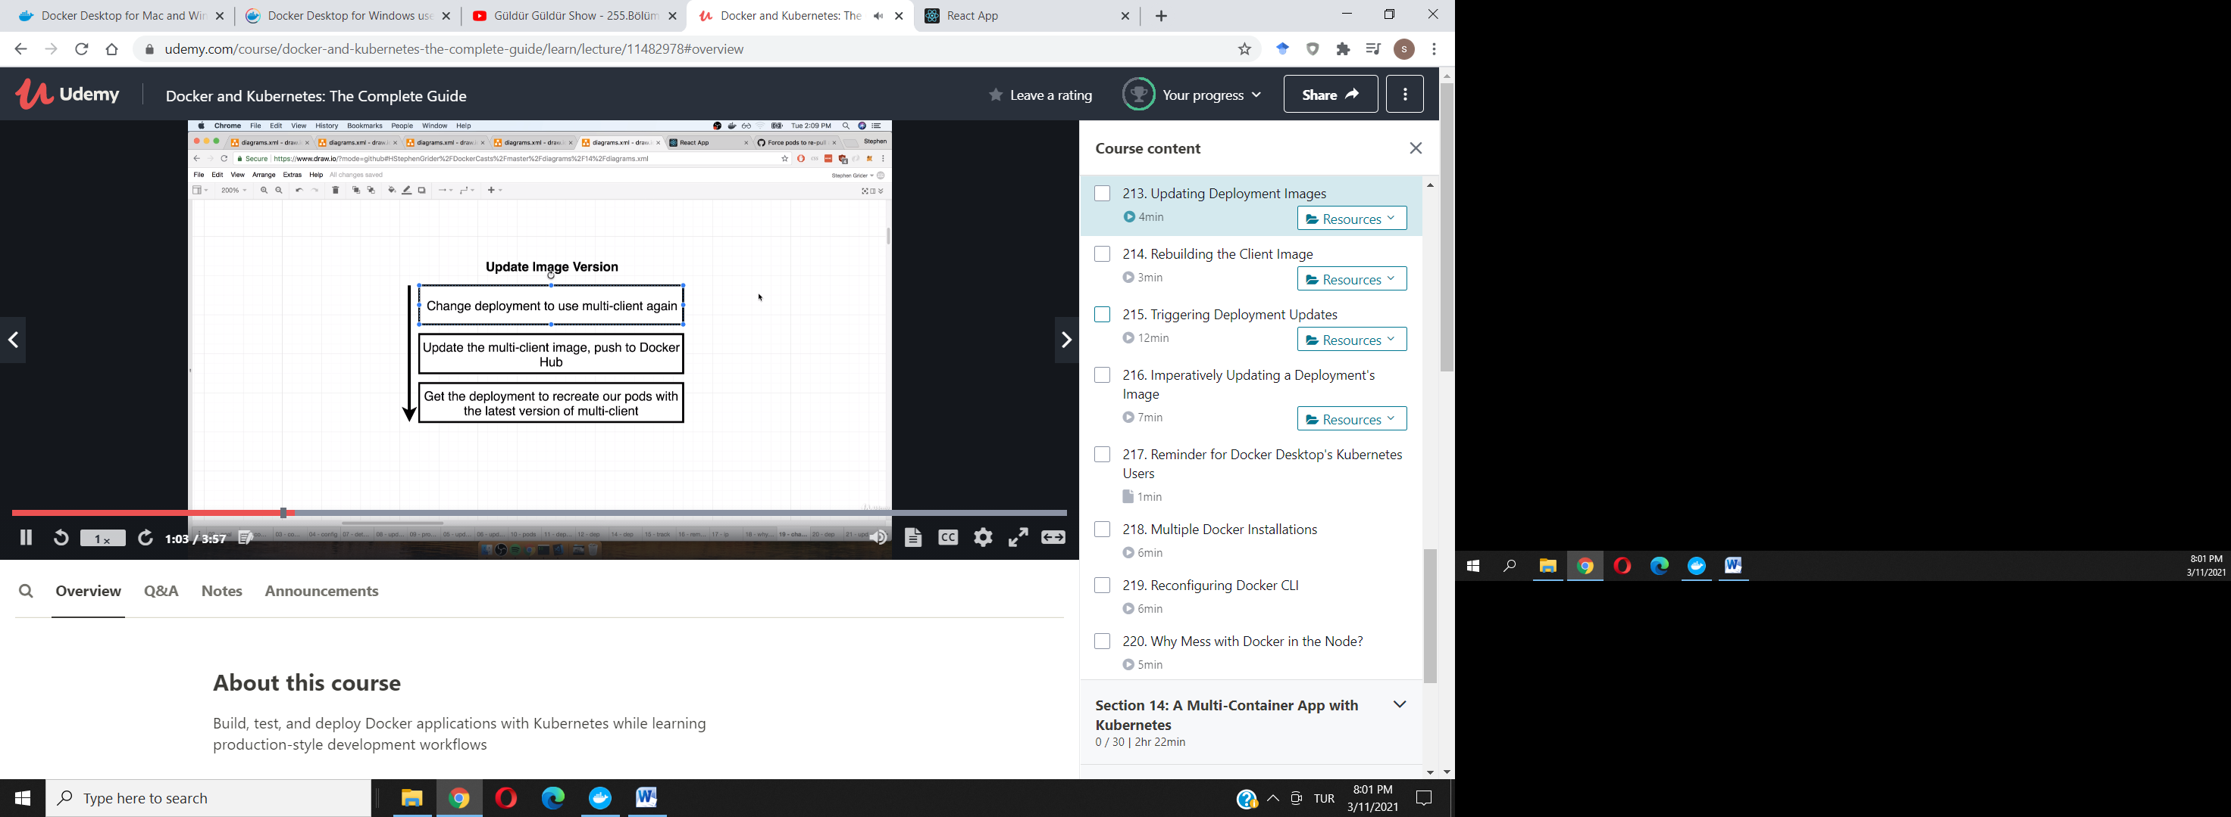

change app.js in client folder in “complex” project folder

then build image again and push to docker hub

$ docker build –t stephengrider/multiclient

$docker push stephengrider/multiclient .

Triggering deployment updates:

